MS Office Excel (Project 6A)
Welcome back! In this next tutorial, I created charts & diagrams to communicate data in a visual way. Charts make a set of numbers easy to understand by showing data in a graphical way. Excel’s SmartArt illustrations make diagrams, like an organizational chart or process cycle, easy to understand.

The Dallas–Fort Worth Job Fair is a nonprofit organization that brings together employers and job seekers in the Dallas–Fort Worth area. Each year, the organization holds targeted job fairs. The fair attracts over 900 employees in more than 75 industries and registers more than 30,000 candidates. Candidate registration is free, because the employers pay a formal fee to show and present at the fairs. Candidate resumes and employer postings are managed by a database system, which allows participants quick, accurate access to job data, and candidate qualifications. The organization wants to see what the attendance patterns have looked like at the fairs over a five-year period. So, I created charts and diagrams.

I selected the range from B4:F10, clicked on “Quick Analysis” in the lower right corner, chose “Sparklines” and clicked “Line”. The sparklines show a quick indication that for most locations, attendance has had an overall upward trend over the five-year period. On the “Design” tab, in the “Show” group, I selected the “High Point” and “Last Point” check boxes. In the “Style” group, I selected the first style in the third row, “Sparkline Style Accent 1, (no dark or light).” Then in cell G3, I typed “Trend.”

A chart is a graphic representation of data. When I create a chart, I need to first decide whether I’ll plot the values representing totals or the values representing details, because I can’t plot both in the same chart. Excel’s Recommended Charts feature helps me make this decision by showing suggested charts, based on patterns in my data. I selected the range from A3 to F10, navigated to the “Insert” tab, went to the “Charts” group, and clicked “Recommended Charts”. In the “Insert Chart” pop-up window, I selected “Clustered Column” and clicked “OK”. Then, I moved the chart to a new worksheet called “Attendance Chart”. In the “Design” tab in the “Type” group, I clicked “Change Chart Type”. In the “Change Chart Type” pop-up window, I changed the chart to “3-D Clustered Column”. Then, I set the style to “Style 3” and the title to “Attendance by Location”. I customized the title with a “Bold Italic” “Font Size” of “20” and a “Theme Color” of “White, Background 1, Darker 50%” with “Small Caps”. I titled my “Vertical Axis” as “Number Attending” with the “Font Size” of “14” and a “Font Color” of “White, Background 1, Darker 50%”. I applied the same font size & color to the Horizontal Axis, but this time, I set the “Font Size” to “12”. Then, I changed cell F5 in the “Attendance by Location” worksheet to “7261”. The last step I took was add shaded walls and floor to my chart. I navigated to the “Chart Tools Format” tab, went to the “Current Selection” group. In the “Chart Elements” drop-down menu, I chose “Back Wall” and clicked “Format Selection. In the “Format Wall” sidebar, I went to the “Fill” section, chose “Solid fill” and clicked the “Fill Color” arrow. Under “Theme Colors”, I chose the fourth color in the fourth column, “Dark Blue, Text 2, Lighter 40%”. Then, I set the “Transparency” to 75%. I followed the same steps for “Side Wall”. But, this time, I set the color to “White, Background 1, Darker 50%” and the “Transparency” to 60%. Next, I repeated this step for the Chart Area with a solid fill color of “Olive Green, Accent 3, Lighter 60%”.

Now that my 3-D clustered column chart is polished, the next chart I created was a line chart. Line charts show trends over time. A line chart can either have one line, such as the price of a company’s stock over time, or it can show more than one line to show a comparison of similar numbers over time. In the “Attendance by Location” worksheet, I selected the range from A3 to F4, navigated to the “Insert” tab, went to the “Charts” group, and selected “Line with Markers” in the first row of “Insert Line or Area Chart”. I titled the chart as “Attendance at Dallas Job Fair” with a font size of “16” and a style of “Bold Italic”. I right-clicked on the vertical axis and chose “Format Axis”. Then, I went to the “Axis Options” section. Under “Bounds”, I set “Minimum” to 5000 and “Major unit” to “1000”. This changed the beginning and ending numbers on the chart and the unit by how the major gridlines show up. The first value starts at 5,000 with major gridlines at intervals of 1,000. This will highlight the change in attendance over the five years. I right-clicked the lines of the graphs, navigated to the “Format” tab, went to the “Current Selection” group, and chose “Plot Area” in the drop-down menu. In the “Format Plot Area” sidebar, I went to the “Fill” section, chose “Solid” and selected the fourth color in the first column, “White, Background 1, Darker 25%.” I right-clicked on the blue lines and chose “Format Data Series”. In the “Format Data Series” sidebar, I chose “Fill & Line”. Under “Line”, I selected “Solid” with a “Width” of “4 pt”. In that same section, I chose “Marker” and went to the “Marker Options” section. I chose the triangle symbol with a “Marker Type Size” of “12”. Under “Fill”, I chose “Solid Fill” with the last color in the first column of theme colors of “White, Background 1, Darker 50%.” In the “Border” section, I chose “No line”.

My closing step in the line chart was adding a trendline. A trendline shows patterns in the data series, mainly a line sloping upward to show increased sales over a period. I navigated to the “Chart Design” tab, went to the “Chart Elements” group, clicked “Add Chart Elements”, and chose “Trendline” with the “Linear” option.

Now that my charts have been created, the last piece of information I added was a SmartArt graphic. A SmartArt graphic is a visual representation of information and ideas. I can create SmartArt graphics by choosing from different layouts to communicate complicated messages and relationships easily. Unlike charts, SmartArt graphics don’t depend on data in a worksheet. Instead, it's a tool that highlights ideas. The organization wants to know how employers can register to have a booth at the job fair. So, I created a process diagram to give them visual aid. In the “Process Chart” worksheet, I navigated to the “Insert” tab, went to the “Illustrations” group, and chose “SmartArt”. When I clicked “SmartArt”, I got a “Choose a SmartArt Graphic” pop-up window.

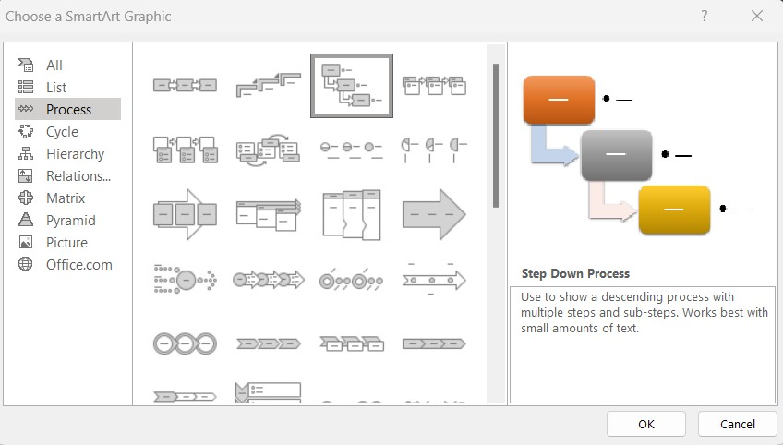
On the left, I chose “Process”, and selected the third option in the first row, “Step Down Process”. When I clicked “OK”, I got two new tabs, “SmartArt Design” & “Format”. I also got an area called the Text Pane. The Text Pane will show the text that I type into my SmartArt graphic. Since the “Step Down Process” graphic shows a descending process with multiple steps and sub-steps, there are indented bullets. I typed the following text in this order:

- Apply
- Register for Booth
- Prepare
- Booth Number Assigned
- Attend
- Set Up Job Fair Booth
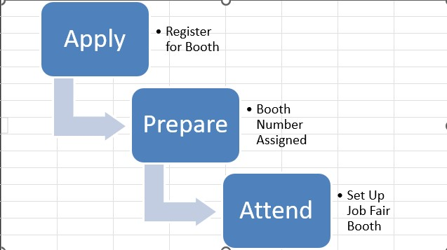
The SmartArt graphic is straight-forward, but it will look even better if I have a polished look. Excel offers pre-formatted SmartArt styles I can use. I navigated to the “Design” tab, went to the “SmartArt Styles” group, chose “More”, and chose the first style, “Polished” under the “3-D” section. In the “Change” Colors” option, I went to the “Colorful” section and chose the third option, “Colorful Range - Accent Colors 3 to 4.”

My second piece of SmartArt was adding an organization chart. An organization chart shows reporting relationships within an organization. It’s basically a family tree in a company. I created an organizational chart that shows the reporting relationship among the Job Fair Director, Employer Relations Manager, Job Applicant Program Manager, Tech Support Supervisor, and Help Desk Technician. Just like I added the SmartArt graphic for the “Process Chart” worksheet, I followed the same process for “Organization Chart” worksheet. But this time, I chose the “Hierarchy”.

In the first text box, I typed “Amanda Shy, Job Fair Director.” Then, I pressed “Enter” and “Tab” after each line and typed the following text:

- Linda Wong, Employer Relations Manager
- Miriam Ruiz, Job Applicant Program Manager
- Michael Gold, Tech Support Supervisor
I selected “Michael Gold, Tech Support Supervisor”, right-clicked, chose “Add Shape”, and clicked “Add Shape Below”. In the new blank shape, I typed “Ivan Soklov, Help Desk Technician.” Then, I applied the “3-D Polished” style with the “Colorful Range - Accent Colors 5 to 6” color. I selected the Ivan Soklov shape, navigated to the “Format” tab, went to the “Shape Styles” group, clicked the “Shape Fill” arrow, and chose the fifth color in the seventh column “Olive Green, Accent 3, Darker 25%.” My last final step was to format the graphics. I went to “Shape Effects”, chose “Bevel”, and selected the second “Riblet” option in the third row.

So, this is how I created charts & diagrams to communicate data in a visual way. Hope this tutorial was helpful and I’ll see you in the next one!

